**Capstone Project Coffee Market Argentina**

**Problem:**

A coffee multinational market place wants to know about the cities of Argentina how many coffee markets they have in every city and how much coffee stores they have in proportion to the population of the city, to be part of this analysis the city must have at least 25000 citizens.

**What do I need?**

The Foursquare API in order to know how many coffee stores every city have.

The Name, Location and number of citizens that every city in the country have.

The skills that I have developed during this whole specialization.

In order to get all the info of the cities of Argentina I will use <https://simplemaps.com/country/ar>

I will update this information to my Github and use the info extracting the data from my Github.

I will use IBM Watson Studio notebooks.

**Methodology**

* Download and process al the info from the cities of Argentina.
* Use Foursquare API to check the amount of coffee stores in every city.
* Analyze both data and merge them together.
* Calculate the rates of every city.

**Results**

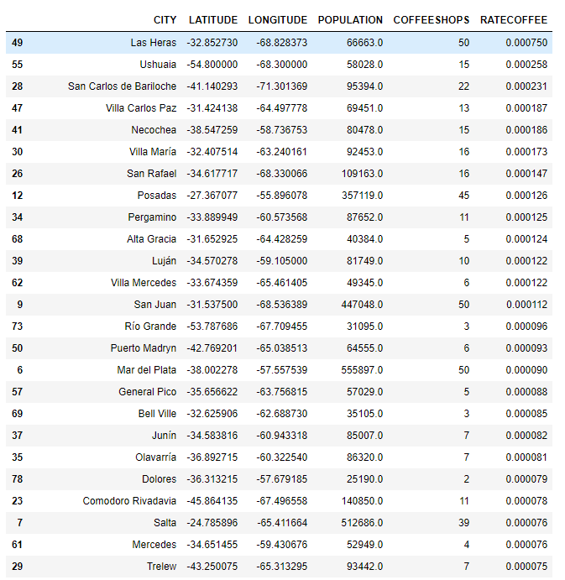

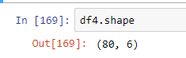

**Observations**

There is a problem with my calls to the Foursquare API, I have the free account version, this put me a limit of 50 to check for coffee stores, this is a huge problem in huge cities like Buenos Aires were the population is 12 millions and of course having 50 coffee stores is not a real data, to solve this I would need a premium or paid account, however in small cities it can be seen that it works properly.

**Conclusion**

We were able to positively rate the amount of coffee store per population in every city, it is needed a premium account to generate 100% real data, this information can be upgraded with financial data in order to know the best places to open coffee stores.